Customer retention ideas! 3 to choose from!
Pink Loyalty Program!
I am so thankful that you have chosen me
to be your Mary Kay girl!
Earn a Pink Point for every $1 you spend with me each quarter!
For every 100 Pink Points you earn, you
will get $10 Pink Bucks towards your next order
in following quarter!
Quarters: June 16-September 15, September 16-December 15,
December 16-March 15, March 16-June 15
Can you use tracking sheet to track and remind when close!

Option #2
I do a client loyalty program that’s quarterly! My clients LOVE IT. It’s morphed over the years- here’s what I do currently:
A $40 reorder= small gift(easy to do a look sampler now)
A $50 reorder= ⬆️ + free chroma eye color.
A $60 reorder= ⬆️ + option to add any 1 item 1/2 price.
A $100 reorder=⬆️ + free lip color or second free eye color.
But the other was great- I’ll prob morph the other part into for every 100$ you purchase you get the $10 Mk bucks to use as my open house next Christmas! People say that’s a great way to get clients to your open house(which I’ve never done)😆
My whole goal was to get my reorders to about $60-$80 instead of $30-$40! It works!
Ps- if I have a reorder that’s already over $60, which qualifies them to have a 1/2 off item, I DO NOT 1/2 one of the items on her order. I just say “hey! I checked your order and it’s so great because your order qualifies you to earn a gift, choose a free chrome eye color and add any 1 additional item 1/2 off! Yay!!!! Let me know which eye color you want, and if you want to take advantage of adding a 50% off item!
Most are savvy and add a lifting serum or other high priced item, but some just add a mascara 1/2 price

Option #3
•All Registered Customers will receive 5% off all their orders, all the time when they shop via my website www.marykay.com........
•I will offer a Product of the Month and customers who spend $50 or more in one transaction (after discount) will receive that product FREE (as their gift with purchase). They must contact me to redeem as it will not be on the website.
•All orders will ship free when they spend over $75.
•Customers can opt to participate in my Beauty Box Offer every month. The box will be customized with 1-2 full size products, up to six samples/minis and other extra goodies. The idea is to have them start using a product they normally wouldn’t. You cannot charge for samples here so mine is a flat rate. Let me know if you have questions.
•Send more thank you cards and emails.
•Build my social media brand
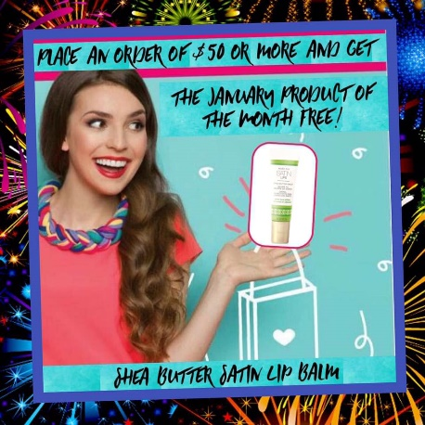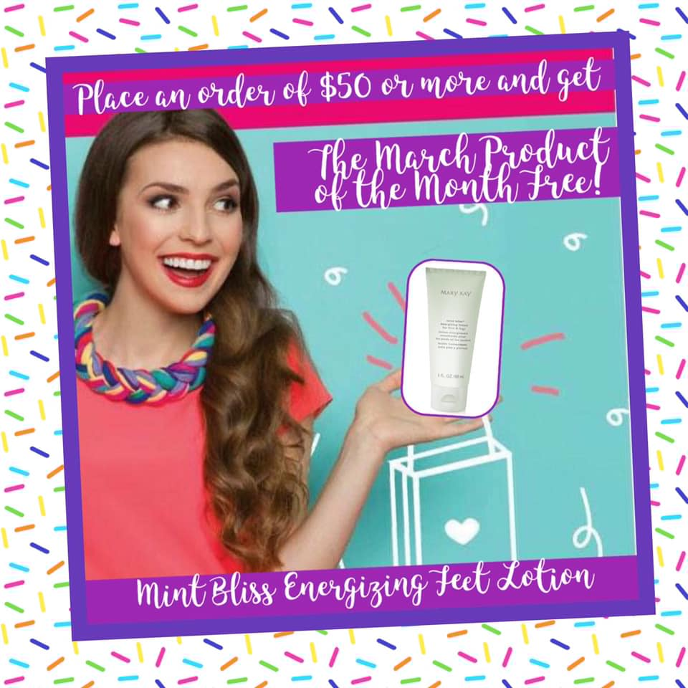

Love on your customers!
I send out a thank you text on the 15th of the month for all orders placed in the previous month.... lots of people respond (good customer relationships) AND many people order AGAIN!
Hi Stacy!! Thank you so much for your order in November! I just wanted to see how you have been enjoying your products! xoxo, Brandi
